**Patient Appointment & Medication Management System**

# 1. Problem Statement

In today's healthcare landscape, efficiency, accessibility, and accuracy are essential. Whether it's a small clinic or a large hospital,  
managing appointments, tracking prescriptions, and staying connected with patients can become overwhelming.  
  
This project brings a fresh, smart solution: a centralized web platform that allows patients to book doctor appointments,  
manage their medications, and access timely health suggestions — all from a secure, user-friendly interface.  
  
Designed with Spring Boot and MongoDB, this solution empowers both patients and healthcare providers to take control of their schedules and treatment journeys.

In many hospitals and clinics, the appointment process is still managed manually or through fragmented systems that are hard to scale or integrate.   
Patients often face long waiting times, unclear appointment slots, and difficulties in accessing or updating their prescriptions.   
Medical professionals, on the other hand, struggle with unorganized patient records, repeated inquiries, and lack of automated reminders for follow-ups or prescriptions.  
  
This project addresses those challenges by offering a full-stack web solution for appointment scheduling, medication management, and doctor-patient interaction within a single streamlined platform.

# 2. Introduction

The Patient Appointment System with Medications is a holistic healthcare platform designed to simplify the patient experience.   
It serves as a digital bridge between patients, doctors, and hospitals, enabling smooth appointment scheduling, effective medicine tracking, and real-time communication.   
The portal is tailored to support hospital workflows and enhance user interaction through a secure, responsive, and intuitive web interface.   
This system addresses the common problems of overcrowded clinics, manual tracking errors, and missed doses by providing automated scheduling and personalized medicine dashboards.

# 3. Technology Used

The application is built using a powerful blend of modern technologies that ensure reliability, security, and extensibility.

- Frontend: Thymeleaf is used for server-side rendering of HTML templates, allowing seamless integration with Spring Boot.

- Backend: Spring Boot serves as the backbone of the application, with modules like Spring MVC for routing, Spring Security for authentication, and WebFlux for reactive features.

- Database: MongoDB provides a flexible NoSQL document-based schema, ideal for dynamic medical records and prescription logs.

- Libraries & Utilities: Lombok reduces Java boilerplate, Spring Validation ensures input correctness, and Springdoc helps generate OpenAPI-compatible documentation.

# 4. The Endpoints

**GET /appointments —** Displays the form used to book new appointments. Pre-populates doctor and date options.

**GET /view —** Returns a list of all appointments associated with the currently logged-in user (doctor or patient).

**POST /api —** Accepts a new appointment booking payload with details like patient ID, doctor, date, time, and reason.

**GET /api/patient/{id} —** Fetches all appointments linked to a specific patient, useful for patient history view.

**GET /api/doctor/{id} —** Returns a list of appointment requests assigned to a particular doctor.

**GET /login —** Loads the login interface where users input their credentials to access the platform.

**GET /register —** Opens the registration form for new users with validation checks.

**POST /register —** Processes the registration form data and creates a new user profile.

**GET /dashboard —** Displays the main dashboard with access to medications, appointments, and doctor lists.

**GET / —** Renders the landing page of the application. Includes navigation to login/register.

# 5. Output Screenshots

## Landing Page (/)

This is the first screen the user encounters. It introduces the platform and provides quick access to login and registration. A clean UI builds trust and guides the user clearly.

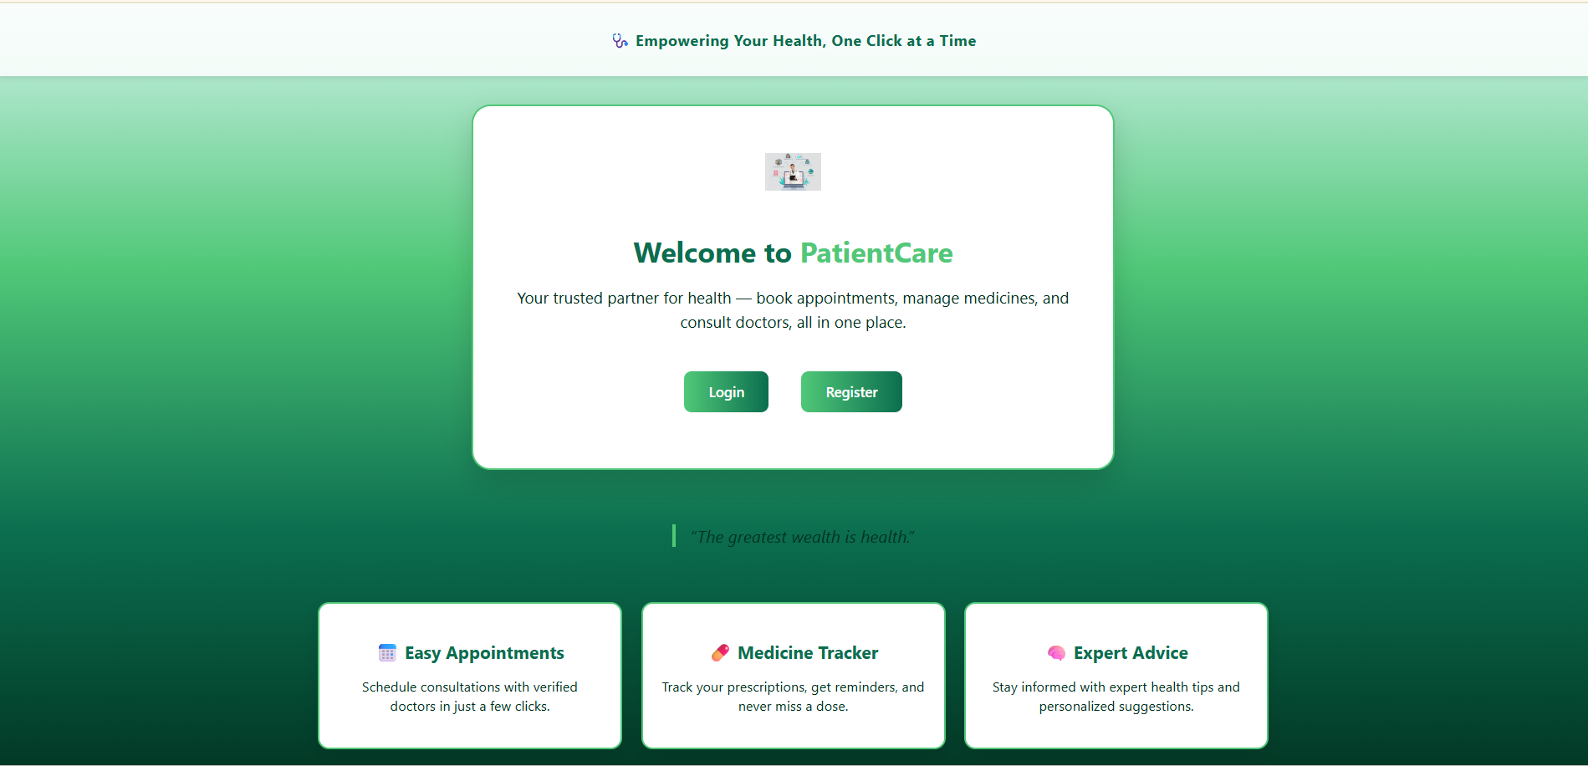

## Login Page (/login)

Here, users (patients, hospitals, doctors) enter their credentials. A simple and secure login mechanism ensures only authorized access.

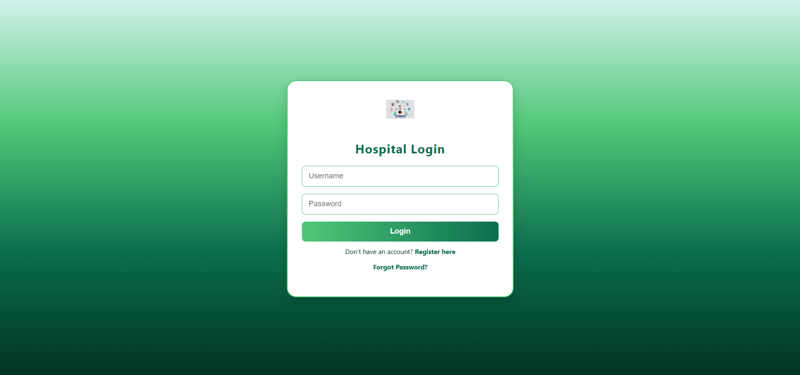

## Register Page (/register)

New users can sign up by entering essential details. This form includes basic validation and is the entry point into the system for patients or hospitals.

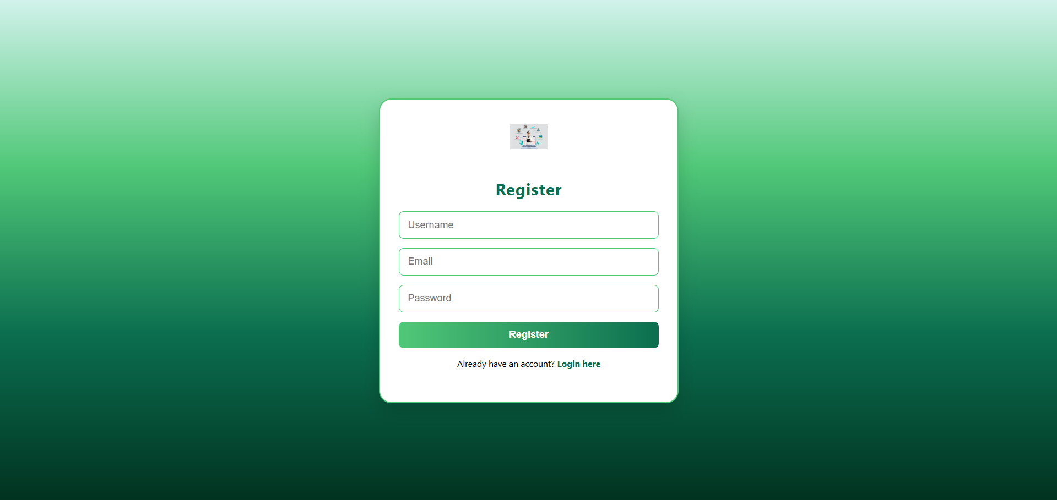

## Forgot Password Page

If users forget their password, they can securely reset it from here using their registered username, promoting accessibility and usability.

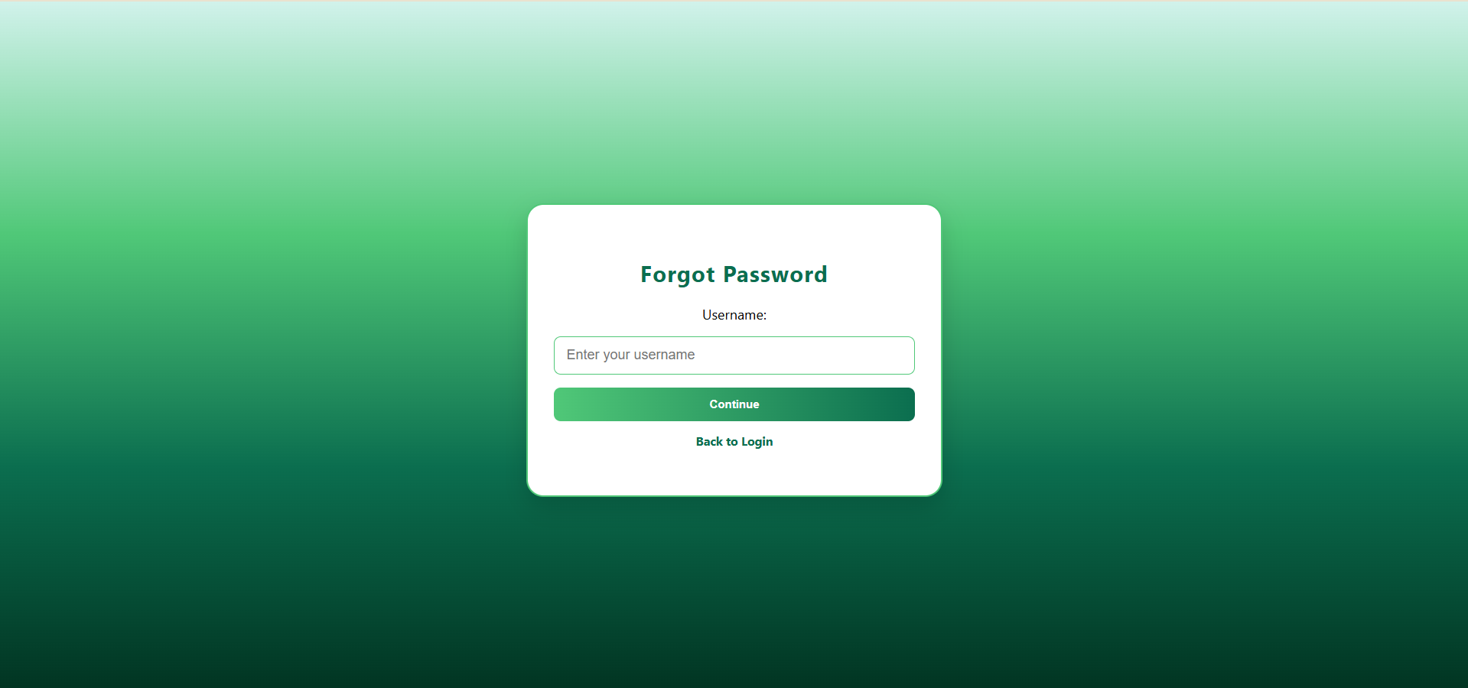

## Dashboard (/dashboard)

After logging in, users land on this dashboard. It provides quick navigation to appointments, medication lists, doctor suggestions, and user-specific data.

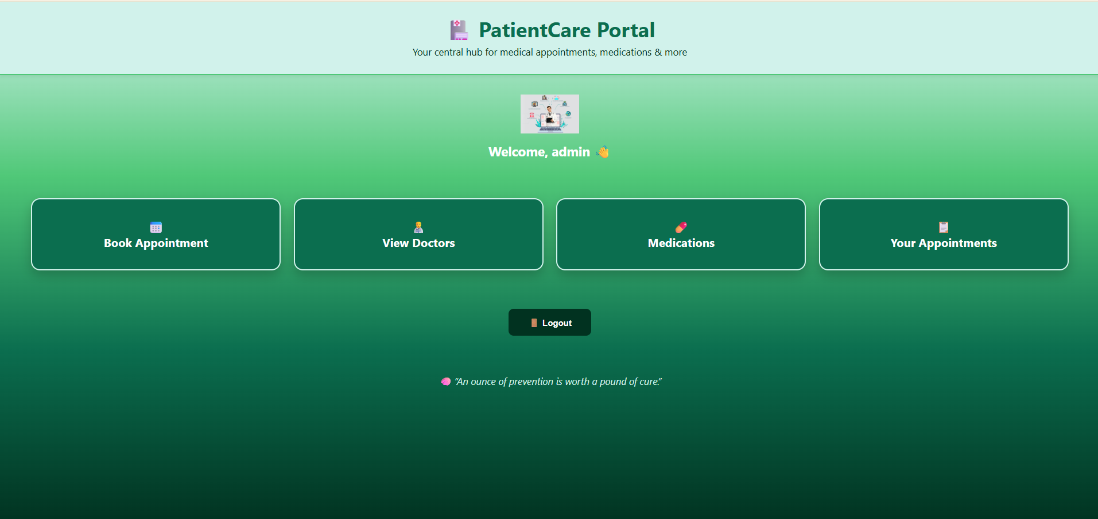

## Book Appointment (/appointments)

Users can book a new appointment by choosing the department, doctor, date, time, and adding a reason. This step is central to the patient flow.

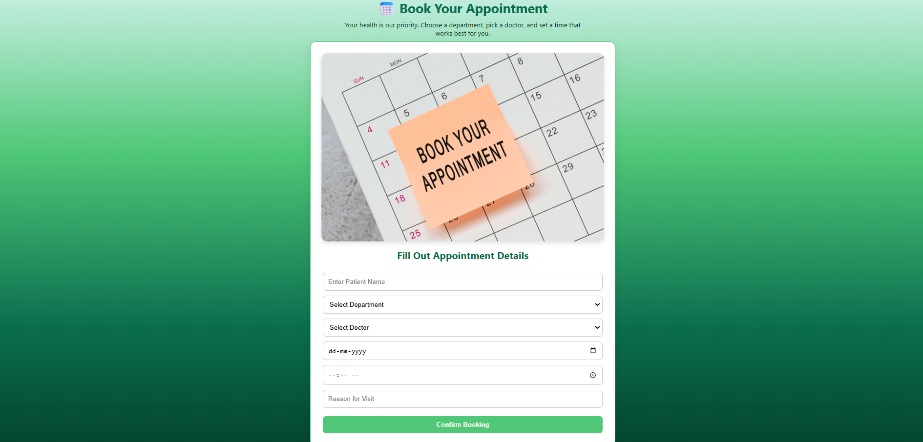

## Doctor List

This view displays all doctors associated with the system. It shows their credentials, helping patients make informed choices before booking.

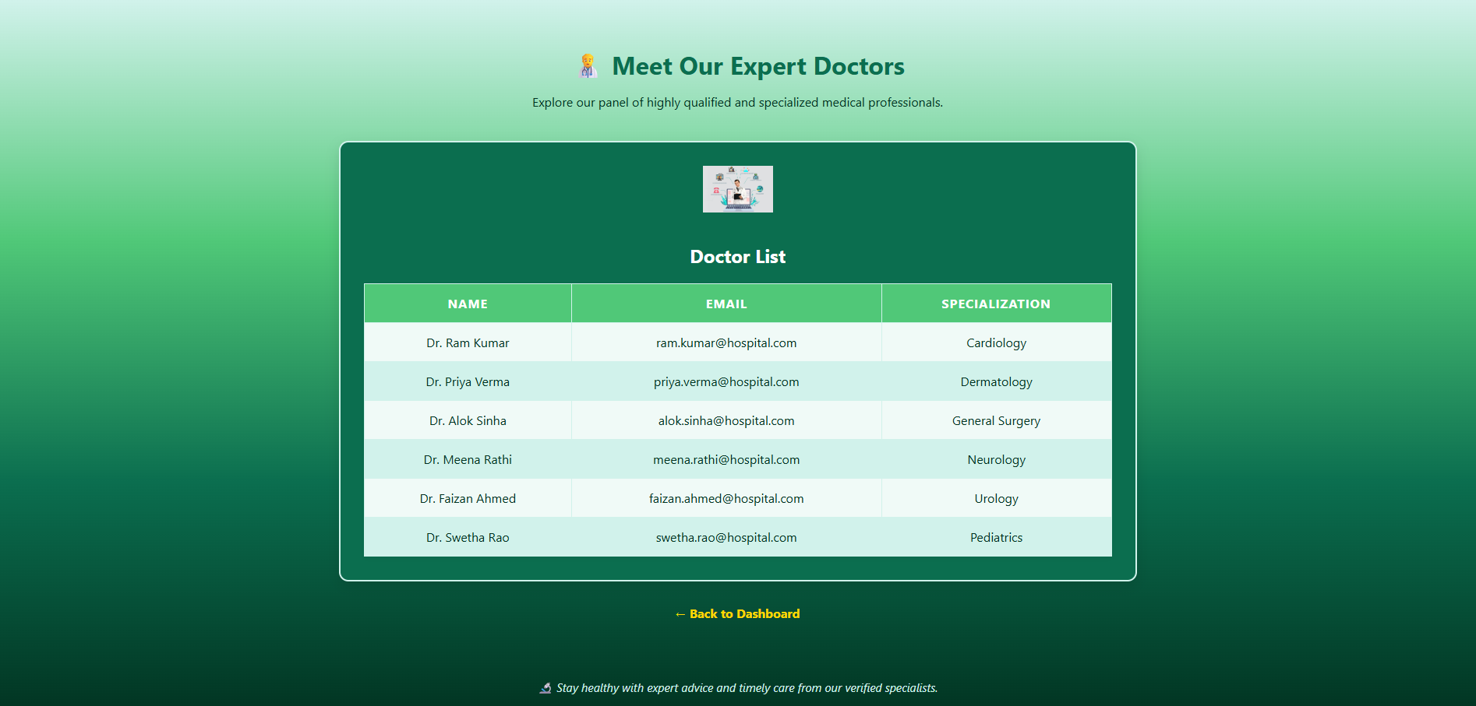

## Medications Page

Doctors can prescribe medications and patients can view them. Each entry shows dosage and timing, helping patients follow their schedule.

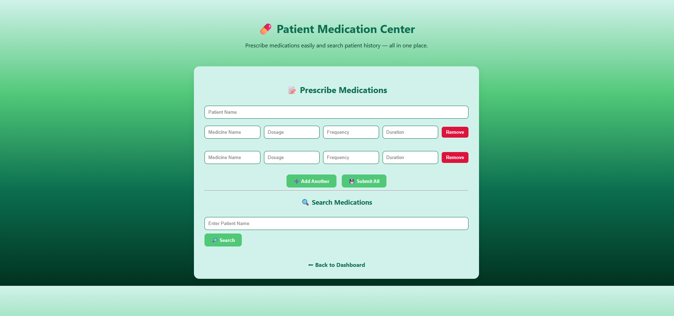

## Appointment List (/view)

Users can view a full history of their appointments, filter based on dates, and access doctor information. Useful for reference and follow-ups.

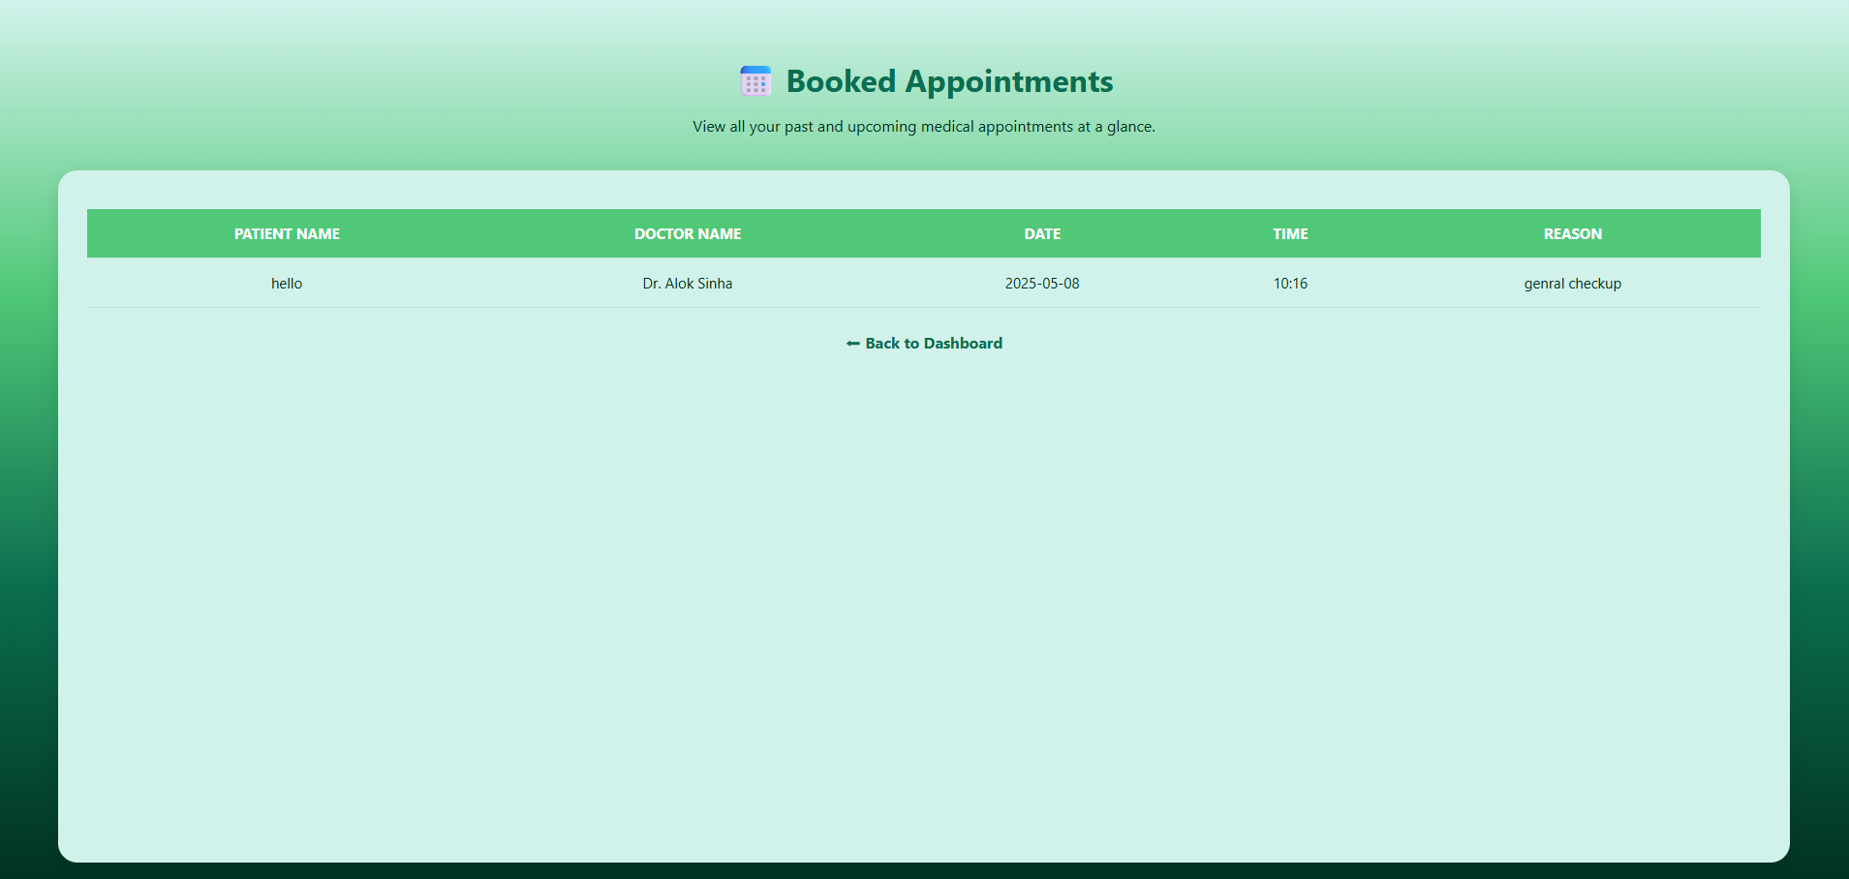

# 6. Conclusion & Future Enhancements

**Modern & Comprehensive Solution**

* Digitizes the entire appointment and medication tracking process.
* Streamlines hospital visits and enhances communication between patients and doctors.

**Built on Scalable Technology**

* Developed using **Spring Boot** (for backend) and **MongoDB** (for flexible NoSQL data storage).
* Designed to easily integrate with third-party services like SMS gateways, payment processors, and AI-based health tools.

**Improves Medication Adherence**

* Ensures patients follow treatment schedules by tracking and reminding them of their prescriptions.

**Customizable & Modular**

* Architecture allows hospitals to plug in additional features based on their specific workflows.
* Promotes long-term adaptability and maintainability.

**Planned Future Enhancements**

**Real-time Video Consultations**

* Allows virtual doctor-patient sessions for remote access and follow-ups.

**Automated Reminders**

* Sends email and SMS alerts for upcoming appointments and scheduled medicine intake.

**Advanced Analytics Dashboards**

* Visualize key data like patient flow, appointment patterns, doctor availability, and more.

**Multilingual Support**

* Enables users to interact in their preferred language, improving accessibility across regions.